Catch-up Premium Plan – Totnes St John’s

Total fund from Catch-up Premium = £10,720

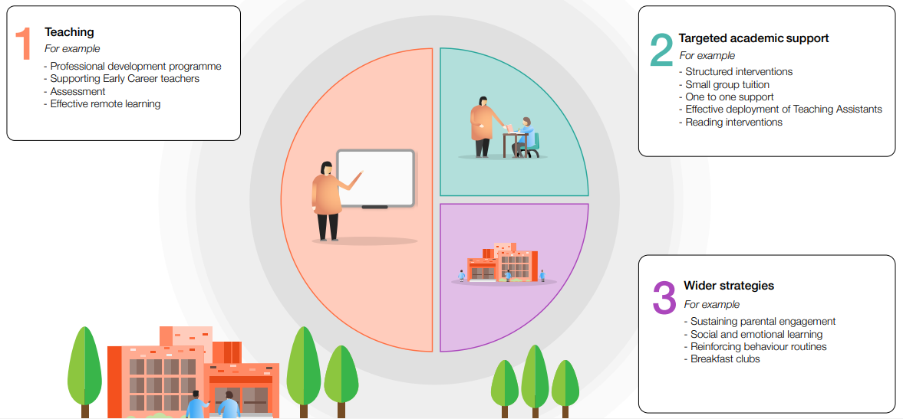
Targeted Academic Support: teach First Mentor £5,720 on costs

Targeted Academic Support RWINc £2,000
Training, development and resources
RWINc development support

Teaching £3,000
Increased professional development of teachers – developing pedagogy of teachers with a focus on Assessment for Learning.
Nick Hind/Trust Leaders/TIG courses

