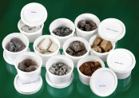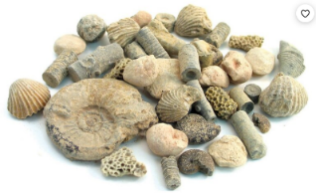

Our thinking tool is ‘Socratic Questions’. A Socratic question is one that probes, challenges and defines thinking.

We’ll also learn how to answer these types of questions by justifying our ideas, adapting ideas and offering more than one solution.

Our gateway is Explorers.

The character value that we are focusing on is aspiration. During this journey we’ll explore what it means to seek a challenge; aspiring to be the best versions of ourselves.

Within this, we’ll learn how to say when we’re finding soemthing hard and how to seek support. When seeeking support, we’ll learn how to break this down into

manageable next steps.

What do you mean by that?

So, are you telling me that…?

Can you repeat that?

Am I right in saying that ….?

What exactly does that mean?

**Character**

Science

* I know that there are three types of rocks and they have different properties and appearances.
* I know that soils are made from rocks and organic matter.
* I know how fossils are formed and which creatures made different fossils.
* I can carry out a fair test, changing only one variable. I can explain why my test is fair; which variable I changed and why.

Writing

* I can use subject specific vocabulary.
* I can use expanded noun phrases to describe.
* I can use subordinators – when/if/that/because.
* I can use a range of punctuation.
* I can consistently form letters correctly and write legibly.

**Knowledge and Skills**

**Key vocabulary**

rock fossil soil

sand properties

compression hard thick brittle sharp soft dense clay silt slate organic matter creatures formation appearance pressure Igneous Sedimentary

Metamorphic

permeable

impermeable

**Previous science learning**

In Year 1/2, we learnt about plants including how to compare and categorise scientifically.

Earlier this year, we investigated materials, including water. Our skills of observation, questioning and experimenting will be built upon in our next journey.

**This learning experience – Rocks and Fossils**

We see rocks all the time, but could we identify different types of rocks and their properties? Could we explain this to someone else? Fossils are harder to come by – why is this and what makes them so special? We will be exploring different types of rock, investigating their properties and grouping them. We will also look more closely at how fossils are made and discover the range of different things that make up the soil that surrounds us all.

**Concepts – Investigation Our Earth Living Things**

**Concepts- Change Systems and Structures Investigation**

**How can I present my scientific knowledge**

**to educate others?**

**Metacognition**

**Outcome**

The children will collaborate, in groups, to create an exhibition of their scientific knowledge to share with the wider school and their families.

**Year 2/3 Science Spring 1**