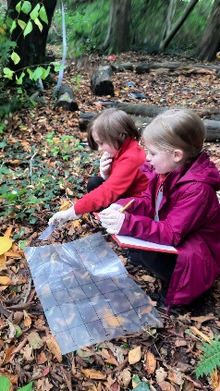
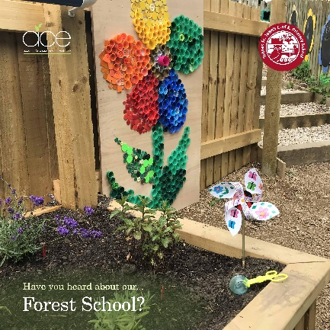
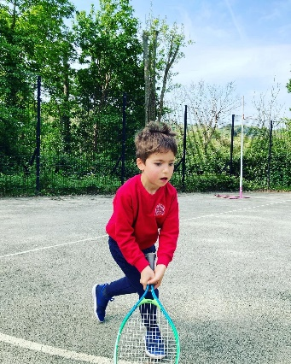

Totnes St John’s Primary

Physical Education and Sport Premium Plan

2023 - 2024

The following working document outlines the intended expenditure of the PESP for the 2023 – 2024 academic year. Throughout the year, the actions completed will be evidenced and evaluated.
Support for review and reflection - considering the 5 key indicators from DfE, what development needs are a priority for your setting and your students now and why? Use the space below to reflect on previous spend, identify current need and priorities for the future.

Key achievements to date: | Areas for further improvement and baseline evidence of need:
See Plan and Evaluation 2022/2023 for full overview:  - Over 60 pupils per week are taking up further opportunities after school  - TAs feel more confident to run sessions at lunch time  - Year 5 leaders are confident to run sessions at lunch and break time.  - Significantly more clubs for KS1 and KS2 pupils  - ACE PE curriculum plan written to ensure coverage and sequencing of learning. A clear Intent, Implementation and Impact.  Attending after school clubs:  - Autumn term 45 pupils per half term  - Spring 56 pupils per half term  - Summer 64 pupils per half term  Achievements in 2022-23 following evaluation  - Lessons observed, PE Lead, shows a high-quality provision where pupils are making excellent progress in a wide-ranging PE offer.  - Pupils recognise their own wellbeing as both physical and mental.  - Pupils understand how they can support their own mental and physical health.  - Pupils know that physical and mental health is linked.  - All KS1&2 pupils took part in outdoor adventure sessions. | The following are areas to develop further in this academic year based on our evaluation of the 2022/23 plan:  - Increase daily exercise for pupils in line with health guidance (30 minutes daily) for all pupils (range of activities available during all break times)  - Increase opportunities for every child in Key Stage 1 to have access to an outdoor education club/forest school/mental health and wellbeing.  - Provide further professional development for staff through personalised support and coaching with a focus on ECTs  - Increase swimming proficiency for pupils who are less confident especially those that are disadvantaged- the expectation is for every child to leave St John’s being able to swim at least 25m in a recognised stroke  - Use the ACE Curriculum document to guide and inform planning and delivery of PE  - Support teachers to implement the ACE PE curriculum with guidance from the PE leader.  - Further increase the number/range of opportunities for pupils to take part in sport festivals

Meeting national curriculum requirements for swimming and water safety | Please complete all of the below:
What percentage of your current Year 6 cohort swim competently, confidently and proficiently over a distance of at least 25 metres?  N.B. Even though your children may swim in another year please report on their attainment on leaving  primary school. | 2021-22: 83% of children left being able to swim at least 25m.  Will be updated in Summer 2024 following final assessment.
What percentage of your current Year 6 cohort use a range of strokes effectively [for example, front crawl, backstroke and breaststroke]? | 2021-22: 58% of children were able to use a range of strokes effectively  Will be updated in Summer 2024 following final assessment.
What percentage of your current Year 6 cohort perform safe self-rescue in different water-based situations? | 2021-22: 42% of children were able to perform self-rescue in different water-based situations  Will be updated in Summer 2024 following final assessment.
Schools can choose to use the Primary PE and Sport Premium to provide additional provision for swimming but this must be for activity over and above the national curriculum requirements. Have you used it in this way? | Yes – Additional swimming is funded (£2,700) in the summer term for those assessed as needing further tuition and confidence.

Action Plan and Budget Tracking
Capture your intended annual spend against the 5 key indicators. Clarify the success criteria and evidence of impact that you intend to measure to evaluate for students today and for the future.

 | Academic Year: 2023/2024 |  |  | Total fund allocated: £17,500 |  |  | Date Updated: September 2023
 | Key indicator 1: The engagement of all pupils in regular physical activity – Chief Medical Officer guidelines recommend that primary school children undertake at least 30 minutes of physical activity a day in school  Key indicator 2: The profile of PESSPA being raised across the school as a tool for whole-school improvement  Key indicator 3: Increased confidence, knowledge and skills of all staff in teaching PE and sport  Key indicator 4: Broader experience of a range of sports and activities offered to all pupils  Key indicator 5: Increased participation in competitive sport |  |  |  |  |  |  |  |  |  | Percentage of total allocation:
 |  |  |  |  |  |  |  |  |  |  | 100% Planned for
 | School focus with clarity on intended impact on pupils: |  | K.I. | Actions to achieve: |  |  | Funding allocated: |  | Evidence and impact:  Ongoing update: Next Update in Nov 2023 |  | Sustainability and suggested next steps:
Increase the opportunities for pupils to participate in competitive activities across a broad range of sports – whilst increasing staff confidence.  Continue to develop the role of sports leader:  - Competitive festivals  - Teaching support  - Play Leader Support |  | 2  3  4  5 |  |  | - All classes to attend a minimum of x 3 sports festivals a year.  - Pupils to compete against other Trust schools in team groups e.g. A, B, C teams.  - All pupils to attend festivals which offer a range of sporting activities – promoting a love for sport.  - Arrange a PE professional development meeting for staff.  - Arrange and deliver ‘toddler’ group multi skill sessions for new families  - Observe staff teaching PE and give feedback  - Arrange Play leader training for Yr 5 pupils.  - Training provided to new TAs to support at lunchtimes effectively | Planned  £3260
Increase pupils’ offer to experience a range of sporting activities through ‘Outdoor Learning’.  Support mental, spiritual and physical well-being of pupils. |  | 1  2  3  4 |  |  | - Train PE Lead in Outdoor Learning with qualified practitioner.  - Every class to have a weekly outdoor learning session  - Create long-term plan which incorporates the school’s progression of values into the PE curriculum. | Planned expenditure  £6300 – Trust-wide support purchased
 | Additional swimming tuition  Provide transport and tuition to extend confident and least confident swimmers in order to meet KS2 expected standards. |  | 2 | Actions for the autumn term 2023  - Identify pupils requiring additional support from 2023.  - Plan bespoke provision for individual swimmers’ needs. |  |  | Planned Expenditure  £2700
 | Further development and confidence of staff teaching across the PE curriculum |  | 3 | - Identify needs of staff who require support – area(s) of PE with less confidence.  - Arrange for Trust-wide support to specifically work alongside staff.  - Assess impact on staff through quality of delivery of PE |  |  | Planned Expenditure  £1780
 | Increase KS1 participation in extra-curricular clubs through an offer which is discounted for families. |  | 1  2  5 | - Arrange for a minimum of x2 sports clubs aimed at KS1 pupils with significant discount.  - Create a system where pupils can rotate through the year to reach maximum opportunities for all.  - Provide questionnaire to families and children to ascertain nature of club offer.  - Open school 15 minutes early and run active morning sessions (including a healthy snack) run by PE lead on the playground/in the hall. SLT to support with children coming into school- families expected to stay and supervise their children during this time. |  |  | Planned Expenditure  Morning club  £1300  +  KS1 Football/ Club  £1605
 | Provide a range of appropriate equipment for staff to plan with so all pupils can be engaged in a variety of experiences.  Replenishment of/new equipment |  | 1  2  4  5 | - Complete inventory of school equipment  - Identify further equipment needs based on pupil and family interests.  - Ensure suitable equipment is ordered for extra-curricular clubs and curriculum PE  - Purchase equipment for lunch time play leaders |  |  | Planned Expenditure  £555

