The Academy for Character and Excellence


Positive Behaviour Policy and Statement of Behaviour Principles

Reference: TP/WP/Curriculum and Standards

Policy date | September 2019 | Statutory Policy - Yes
Strategic Board Approval | October 2021
Reviewed and Updated | July 2023
Next Review Date | October 2024 | Review cycle every 2 years
Author | Head of Safeguarding and Inclusion | www.acexcellence.co.uk
MAT Schools | St Gabriels Primary  Shaldon Primary  Collaton St Mary  Galmpton Primary  Totnes St John’s Primary | Newtown Primary  Berry Pomeroy Primary

Contents
About this policy 2
General principles when applying the policy 2
Aims and Objectives 2
1. Aims 3
2. Legislation and statutory requirements 3
3. Definitions 3
4. Bullying 4
5. Roles and responsibilities 5
6. Pupil code of conduct 5
7. Rewards and sanctions 6
8. Behaviour management 7
9. Pupil transition 8
10. Training 8
11. Monitoring arrangements 8
12. Links with other policies 8
Appendix 1: written statement of behaviour principles 9
Appendix 2 – Positive Behaviour Reward System 10
KS2 Consequences Error! Bookmark not defined.

About this policy
This is the Positive Behaviour policy for the Academy for Character and Excellence

General principles when applying the policy
The purpose of the policy is to promote good behaviour with a view to:
- promoting, among pupils, self-discipline and proper regard for authority,
- encouraging good behaviour and respect for others on the part of pupils and, in particular, preventing all forms of bullying among pupils,
- securing that the standard of behaviour of pupils is acceptable,
- securing that pupils complete any tasks reasonably assigned to them in connection with their education, and
- otherwise regulating the conduct of pupils.

When making any decision under this policy it is particularly important that each pupil is treated as an individual having regard to their particular needs. It is particularly important that if a child has a disability (or special educational needs) that these are appropriately taken into account. For children with disabilities it is important that reasonable adjustments are actively considered. Further, when applying this policy any protected characteristics (such as race, disability, sexual orientation) are taken into account.
Any concerns about discrimination should be addressed urgently with a senior leader. Further, when making any decisions it is important to treat pupils fairly which means making sure that they understand what they have done and having the opportunity to express their views.
Further, a child's behaviour (especially if out of character) may be related to safeguarding issues and as such staff should always be alert to safeguarding issues or other unmet needs. If this is suspected then advice should be sought from a senior leader urgently.
It is also important to be aware that corporal punishment is never permitted. Reasonable force may be used but any exercise of any force must be regarded as a last resort and then only used with great care and when suitably trained.
More than very minor disciplinary measures (such as basic reprimands/warnings) should also be recorded.

Aims and Objectives
It is fundamental to a good education that everyone in the school environment behaves appropriately and treat each other with respect. The goal of school discipline is primarily to assist the development of good character and learning. While punishment is an essential part of enabling pupils to understand consequences, it is not an objective in itself.
Good behaviour should be actively encouraged and rewarded at all times.
Further, the values and ethos of the school should be taken into account when making any decision. This will also include principles of British values properly taking into account any legal requirements and fairness.
Pupils need to understand and know why good discipline is important and the consequences of poor behaviour. This may include explaining the expectations of society about what it is to be a good person and why good behaviour will help them in their personal relationships and also prepare them for the world of work. They should also understand that bad behaviour, if left uncorrected, can lead to serious problems later in life.
The approach towards school discipline should start by properly explaining to a pupil why their behaviour has fallen below expectations and where appropriate, giving them the opportunity to put things right. This may be by making an apology or taking other steps to rectify any wrong doing.
Discipline should be proportionate and appropriate and also applied consistently across all pupils.
Where possible and appropriate pupils should be actively encouraged to participate in decision making about particular class rules so that they may be personally committed to any rules formed.
When giving any sanction it is important to treat the pupil as an individual and take into account any particular circumstances. So, if detaining a student, any wider impact on them should be considered.
Families need to be aware of and must also always be encouraged to support good behaviour.

1. Aims
This policy aims to:
- Provide a consistent approach to behaviour management
- Define what we consider to be unacceptable behaviour, including bullying
- Outline how pupils are expected to behave
- Summarise the roles and responsibilities of different people in the school community with regards to behaviour management
- Outline our system of rewards and sanctions

2. Legislation and statutory requirements
This policy is based on advice from the Department for Education (DfE) on:
- Behaviour and discipline in schools
- Searching, screening and confiscation at school
- The Equality Act 2010
- Use of reasonable force in schools
- Supporting pupils with medical conditions at school
It is also based on the special educational needs and disability (SEND) code of practice.
In addition, this policy is based on:
- Schedule 1 of the Education (Independent School Standards) Regulations 2014; paragraph 7 outlines a school’s duty to safeguard and promote the welfare of children, paragraph 9 requires the school to have a written behaviour policy and paragraph 10 requires the school to have an anti-bullying strategy
- DfE guidance explaining that academies should publish their behaviour policy and anti-bullying strategy online
This policy complies with our funding agreement and articles of association.

3. Definitions
Misbehaviour is defined as:
- Disruption in lessons, in corridors between lessons, and at break and lunchtimes
- Non-completion of classwork or homework
- Poor attitude
- Incorrect uniform
Serious misbehaviour is defined as:
- Repeated breaches of the school rules
- Any form of bullying
- Sexual assault, which is any unwanted sexual behaviour that causes humiliation, pain, fear or intimidation
- Vandalism
- Theft
- Fighting
- Smoking
- Racist, sexist, homophobic or discriminatory behaviour
- Possession of any prohibited items. These are:
  - Knives or weapons
  - Alcohol
  - Illegal drugs
  - Stolen items
  - Tobacco and cigarette papers
  - Fireworks
  - Pornographic images
  - Any article a staff member reasonably suspects has been, or is likely to be, used to commit an offence, or to cause personal injury to, or damage to the property of, any person (including the pupil)

4. Bullying
Bullying is defined as the repetitive, intentional harming of one person or group by another person or group, where the relationship involves an imbalance of power.
Bullying is, therefore:
- Deliberately hurtful
- Repeated, often over a period of time
- Difficult to defend against

Bullying can include:

Type of bullying | Definition
Emotional | Being unfriendly, excluding, tormenting
Physical | Hitting, kicking, pushing, taking another’s belongings, any use of violence
Racial | Racial taunts, graffiti, gestures
Sexual | Explicit sexual remarks, display of sexual material, sexual gestures, unwanted physical attention, on-line sexual coercion, comments about sexual reputation or performance, or inappropriate touching
Direct or indirect verbal | Name-calling, sarcasm, spreading rumours, teasing
Cyber-bullying | Bullying that takes place online, such as through social networking sites, messaging apps or gaming sites

Details of our school’s approach to preventing and addressing bullying are set out in our anti-bullying policy.

5. Roles and responsibilities

5.1 The Local Committee
The Local Committee is responsible for monitoring this behaviour policy’s effectiveness and holding the headteacher to account for its implementation.

5.2 The headteacher
The Headteacher, in consultation with the Trust’s Head of Safeguarding and Inclusion, is responsible for reviewing and approving this behaviour policy.
The headteacher will ensure that the school environment encourages positive behaviour and that staff deal effectively with poor behaviour, and will monitor how staff implement this policy to ensure rewards and sanctions are applied consistently.

5.3 Staff
Staff are responsible for:
- Implementing the behaviour policy consistently
- Modelling positive behaviour
- Providing a personalised approach to the specific behavioural needs of particular pupils
- Recording behaviour incidents
The senior leadership team will support staff in responding to behaviour incidents.

5.4 Families
Families are expected to:
- Support their child in adhering to this policy and the pupil code of conduct (see below)
- Inform the school of any changes in circumstances that may affect their child’s behaviour
- Discuss any behavioural concerns with the class teacher promptly

6. Pupil code of conduct

Pupils are expected to:
- Behave in an orderly and self-controlled way
- Show respect to members of staff and each other
- In class, make it possible for all pupils to learn
- Move quietly around the school
- Treat the school buildings and school property with respect
- Wear the correct uniform at all times
- Accept sanctions when given
- Refrain from behaving in a way that brings the school into disrepute, including when outside school

7. Rewards and sanctions

7.1 List of rewards and sanctions
Positive behaviour will be rewarded with:
- Praise
- Rewards
- Letters or phone calls home to families
- Special responsibilities/privileges

The school may use one or more of the following sanctions in response to unacceptable behaviour:
- A verbal reprimand
- Sending the pupil out of the class
- Expecting work to be completed at home, or at break or lunchtime
- Detention at break or lunchtime.
- Referring the pupil to a senior member of staff
- Letters or phone calls home to Families
- Agreeing a behaviour contract

We may use internal exclusion in response to serious or persistent breaches of this policy. Pupils may be sent to the Headteacher during lessons if they are disruptive, and they will be expected to complete the same work as they would in class.
The internal exclusion is managed by a member of the Senior Leadership team.

7.2 Off-site behaviour
Sanctions may be applied where a pupil has misbehaved off-site when representing the school, such as on a school trip or on the bus on the way to or from school.

7.3 Malicious allegations
Where a pupil makes an accusation against a member of staff and that accusation is shown to have been malicious, the headteacher will discipline the pupil in accordance with this policy.
Please refer to our Safeguarding Policy for more information on responding to allegations of abuse.
The headteacher will also consider the pastoral needs of staff accused of misconduct.

8. Behaviour management

8.1 Classroom management
Teaching and support staff are responsible for setting the tone and context for positive behaviour within the classroom.
They will:
- Create and maintain a stimulating environment that encourages pupils to be engaged
- Display the pupil code of conduct or their own classroom rules
- Develop a positive relationship with pupils, which may include:
  - Greeting pupils in the morning/at the start of lessons
  - Establishing clear routines
  - Communicating expectations of behaviour in ways other than verbally
  - Highlighting and promoting good behaviour
  - Concluding the day positively and starting the next day afresh
  - Having a plan for dealing with low-level disruption
  - Using positive reinforcement

8.2 Physical restraint
In some circumstances, staff may use reasonable force to restrain a pupil to prevent them:
- Causing disorder
- Hurting themselves or others
- Damaging property
Incidents of physical restraint must:
- Always be used as a last resort
- Be applied using the minimum amount of force and for the minimum amount of time possible
- Be used in a way that maintains the safety and dignity of all concerned
- Never be used as a form of punishment
- Be recorded and reported to Families

8.3 Confiscation
Any prohibited items (listed in section 3) found in pupils’ possession will be confiscated. These items will not be returned to pupils.
We will also confiscate any item which is harmful or detrimental to school discipline. These items will be returned to pupils after discussion with senior leaders and Families, if appropriate.
Searching and screening pupils is conducted in line with the DfE’s latest guidance on searching, screening and confiscation.

  - Pupil support
The school recognises its legal duty under the Equality Act 2010 to prevent pupils with a protected characteristic from being at a disadvantage. Consequently, our approach to challenging behaviour may be differentiated to cater to the needs of the pupil.
The school’s special educational needs co-ordinator will evaluate a pupil who exhibits challenging behaviour to determine whether they have any underlying needs that are not currently being met.
Where necessary, support and advice will also be sought from specialist teachers, an educational psychologist, medical practitioners and/or others, to identify or support specific needs.
When acute needs are identified in a pupil, we will liaise with external agencies and plan support programmes for that child. We will work with Families to create the plan and review it on a regular basis.

9. Pupil transition
To ensure a smooth transition to the next year, pupils have transition sessions with their new teacher(s). In addition, staff members hold transition meetings.
To ensure behaviour is continually monitored and the right support is in place, information related to pupil behaviour issues may be transferred to relevant staff at the start of the term or year. Information on behaviour issues may also be shared with new settings for those pupils transferring to other schools.

10. Training
Our staff are provided with training on managing behaviour, including proper use of restraint, as part of their induction process where required.
Behaviour management will also form part of continuing professional development.
A staff training log can be found in appendix 3.

11. Monitoring arrangements
This behaviour policy will be reviewed by the headteacher and Local Committee every 2 years. At each review, the policy will be approved by the headteacher.

12. Links with other policies
This behaviour policy is linked to the following policies:
- Exclusions policy
- Safeguarding policy

Appendix 1: written statement of behaviour principles



- Every pupil understands they have the right to feel safe, valued and respected, and learn free from the disruption of others
- All pupils, staff and visitors are free from any form of discrimination
- Staff and volunteers set an excellent example to pupils at all times
- Rewards, sanctions and reasonable force are used consistently by staff, in line with the behaviour policy
- The behaviour policy is understood by pupils and staff
- The exclusions policy explains that exclusions will only be used as a last resort, and outlines the processes involved in permanent and fixed-term exclusions
- Pupils are helped to take responsibility for their actions
- Families are involved in behaviour incidents to foster good relationships between the school and pupils’ home life

The Local Committee also emphasises that violence or threatening behaviour will not be tolerated in any circumstances.

Appendix 2 – Positive Behaviour Reward System

Children are celebrated in their class and across the school community when they exemplify our values: aspiration, responsibility, compassion, determination and honesty. There are a number of different ways to reward and recognise the children’s efforts and achievements. We recognise the importance of clear and consistent communication with families to keep them up-to-date with their child’s journey through school.

Basic Behaviours for Learning

We feel that is important to explicitly teach a behaviour curriculum and we have three core principles which are clearly displayed across the school. These core principles can be adapted and individualised to allow all children to be successful.
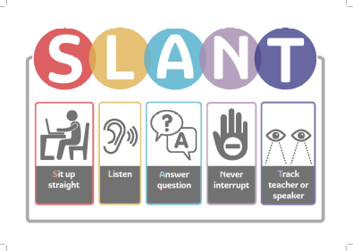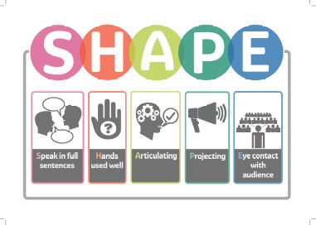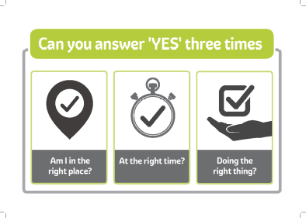

Individual Dojo Points

Children receive Class Dojo points to reward them for displaying our values.

Class Values Display

When children have exemplified the values in school, we feel it is important to celebrate them as an example within their peer community. A postcard linked to one of our values will be added to the class display to capture the moment- this will be sent home at the end of the term. They will also be presented with a silver certificate to share with their families.

School Values display

In order to promote excellence when demonstrating our school values, a child can be added to the school values display in our hall as a shining example of our values in action. They will be presented with a gold certificate to share with their families as part of a school worship.

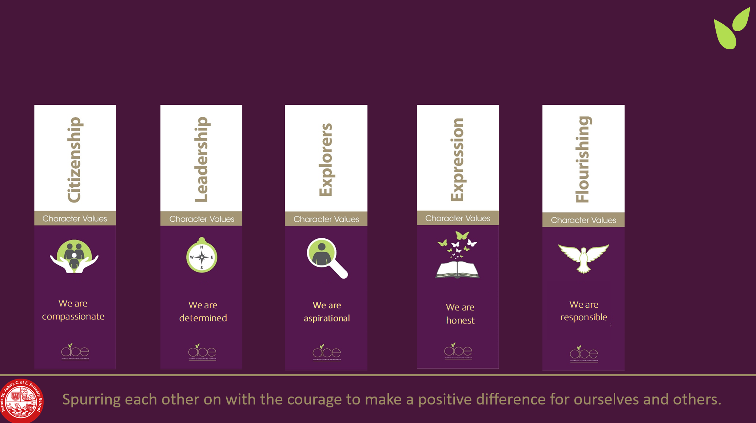

Consequences to support positive behaviour

At Totnes St John’s, we know that relationships are the foundation to every aspect of a child’s journey through school and that it is vital that there is mutual respect and trust between adults and children.
We feel that is important to have high expectations of the children in all areas and it is our responsibility to support the children to make positive behaviour choices. Therefore, we use a range of consequences that can be adapted.

Escalation Process
Our staff are skilled in behaviour management and will teach these learning behaviours in a positive and encouraging way.

Visual Reminder | Pupils will be given a visual cue to draw their attention back to expected standard of behaviour.
Verbal Reminder | Pupils will be given a verbal reminder to draw their attention back to expected standard of behaviour.
One to one Conversation | Pupils who continue to struggle to keep to the expected behaviour standard will meet with an adult to discuss what support they may require and what responsibilities they have.
Reflection | Pupils who were unable to take ownership of their behaviour will meet with a member of staff at break or lunch time. During this meeting, pupils will complete an age-appropriate reflection to unpick the causes and next steps for the child and supporting adults- this will include discussing what other support can be put in place for the child to have a successful rest of the day.  Class teacher will keep family updated.  Two reflections in a week will require a family meeting with class teacher.  SLT to analyse trends to better support children.
Change of Enviroment | Pupils can require a change of enviroment to help them reset with the help of a different adult. During this time, appropriate work will be set by the class teacher to support them in returning to class successfully.
Report Card | A report card process is a strategy that can be put in place to support children who continue struggle. This allows us to provide regular updates for the children and families and we can also identify any patterns in behaviour.
Suspension | Where the behaviour policy has been breached the headteacher will use their professional judgement based on the individual circumstances of the case when considering whether to suspend a pupil.  The reasons below are examples of the types of circumstances that may warrant a suspension.  - Physical assault against a pupil  - Physical assault against an adult  - Verbal abuse or threatening behaviour against a pupil  - Verbal abuse or threatening behaviour against an adult  - Use, or threat of use, of an offensive weapon or prohibited item that has been prohibited by a school’s behaviour policy  - Bullying  - Racist abuse  - Abuse against sexual orientation or gender reassignment  - Abuse relating to disability
Exclusion | Where the behaviour policy has been breached the Headteacher will use their professional judgement based on the individual circumstances of the case when considering whether to exclude a pupil.  The reasons below are examples of the types of circumstances that may warrant a permanent exclusion.  - Physical assault against a pupil  - Physical assault against an adult  - Verbal abuse or threatening behaviour against a pupil  - Verbal abuse or threatening behaviour against an adult  - Use, or threat of use, of an offensive weapon or prohibited item that has been prohibited by a school’s behaviour policy  - Bullying  - Racist abuse  - Abuse against sexual orientation or gender reassignment  Abuse relating to disability

The school or Trust may also use the following sanctions:
- Limiting pupils access to extra-curricular clubs and co-curricular provision (e.g. swimming)
- Removal of IT rights (e.g. internet access)
- Confiscation of item/s
- Not allowing pupils to attend recognition expeditions or residential.
- Removal of unstructured time e.g. break time
- Reduced timetable
- Directing the pupil to an alternative provision / managed move
- Extended reflection time outs
- Permanent exclusion

Time Out Reflection Sheet

What happened? | How did I feel?
What can I do to help myself? | What can the adults do to support me?

Name of child ………………………………………………………………………..

Date…………………………………………… Time………………………..
Appendix 3: staff training log
Training received | Date completed | Trainer/training organisation | Trainer’s signature | Staff member’s signature | Suggested review date

